

Module : Problem Solving
Semester and Year : October 2022 Semester
Date of Submission : 11 November 2022
Name : Jesslyn Boediono Goenawan
Student ID number : 10245280

Project Report
From the python codes, we have completed to make the quiz mini program for the primary students, we will give them some random math questions for practice. Your output after you run (F5) it and to stop we can use (Shift + F5):
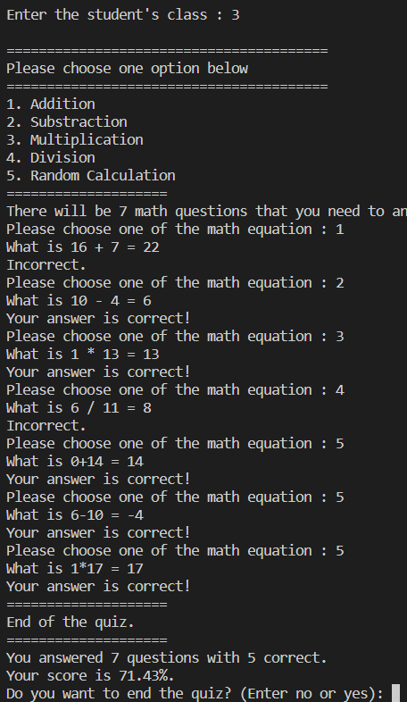
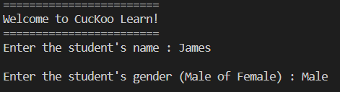
First of all, we will make the opening program design, we use def logo() for the headings (the quiz program name) to start the program. Afterwards, we make lists of students’ data that is exist in the list = [], then the user can input (according to the list) for student’s name, gender, and class. If we input the name or gender or class that are outside of the list, then the program will instantly shut down. We put some more design display before the math menu choices. Below that, we give 5 options of math equation that allow the user to choose in the next input. If the user input “1” then the ‘addition’ math question will show up, the same if entering number “2”, the user will get the subtraction question, will continue repeatedly per question until 7 times. We use the list to order the options menu. The user will be asked to try and input again if the user input the option number more than number “5”. Every time the user finished answering the math question, the program will notify whether the user’ answer is correct or incorrect. From there, we can calculate the total of correct answers by using counter or variable ‘i’ inside of a for loop.
After that, we put more program design into the code. We then show how many questions have the user’s answered and also with the amount of correct answer. We then calculate the student’s score with “result = correct / total” and then to make it percentage by “round((result *100), 2)”.
After the mathematical program, we ask the user whether they want to end the quiz or not. The output should be:
If we input “no”, the program will start from the very beginning and will end with the same exit question. We will retry the program again:
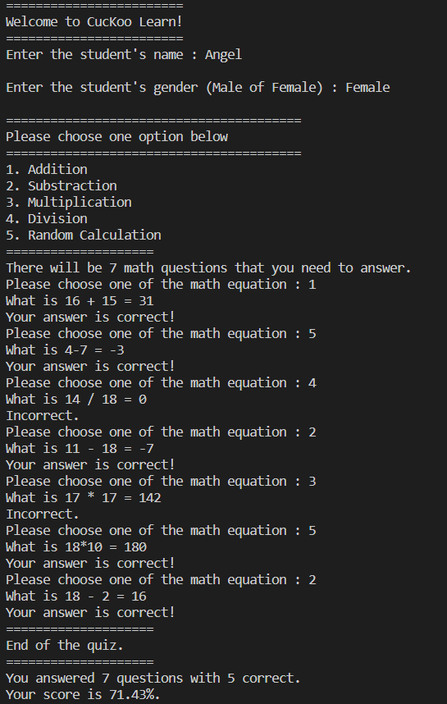
We still can input the same student’s name, although the score is individual (reset every time user doesn’t end the quiz or restart the quiz program).

However, if we input “yes”, the program will automatically quit and stop the whole program.
For this mini program, we will be using a lot of def functions, the use is to group up some of the program such as the display, registration, math choices, math questions, the scoring, and others. From there we can easily make the program output order without crashing codes between each section, also to make the code more convenient to view and to help the debug (wrong codes or syntax error). The flowcharts below will give a better view of each section of codes.
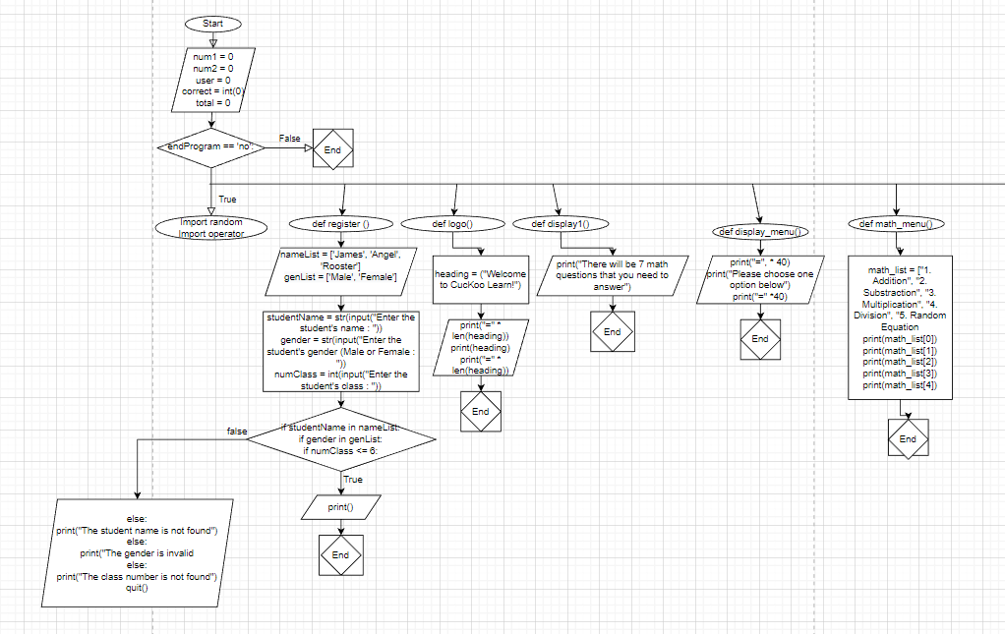
Flowcharts
A
A

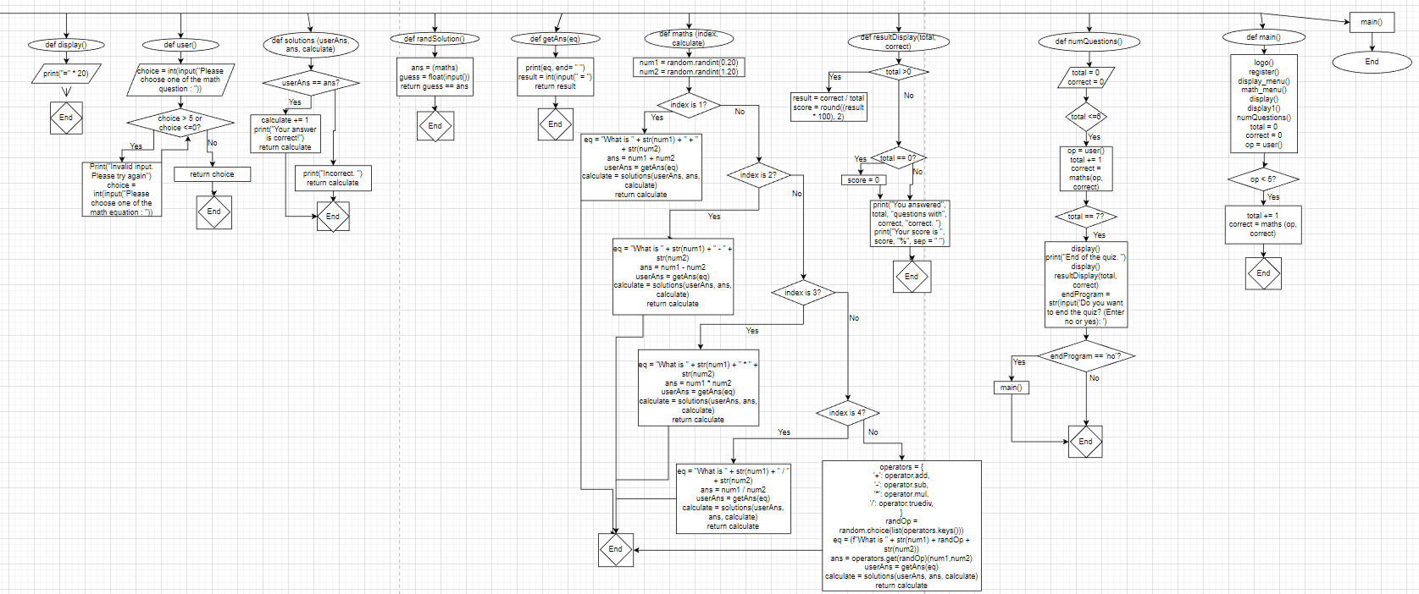
Python Codes

